Vancouver Coastal Health

Standard Operating Procedure

VCH Regional End of Life Quarterly Report

May 2018

Contents

**Report Overview** 3

**Indicator Preparation:** 4

Percent of Overall Hospital Deaths for Clients Known to VCH Community Program 4

Average Hospital Days in the Last 6 Months of Life for Clients Known to VCH Community Program 5

**Calculating Year to Date (YTD) values** 6

**Preparing the Palliative Balance Scorecard** 6

Updating the BSI 6

Updating the Comments for BSI 8

Palliative Scorecard 9

**Quality Checks** 9

Excel Files 9

Palliative Scorecard 9

**Second Round of Quality Checks** 10

Palliative Scorecard 10

**Updating the DASH** 10

**Final Steps** 10

# **Report Overview**

The Regional End-of-Life Report is designed specifically for palliative services. The report contains Percent of Overall Hospital Deaths for Clients Known to VCH Community Program and Average Hospital Days in the Last 6 Months of Life for Clients Known to VCH Community Program.

**Report Audience:**

Director and Program Lead for Older Adult & End of Life Care, Director of Home and Community Care, Regional Medical Director for Home and Community Care, Regional Leader End of Life Care, Vice President, Community Services, Project Manager IPACE (Full list of those receiving this report can be found at the end of this report)

**Report Timeline:**

By Quarter. Usually data is available a week after the quarter ends.

**Report Location:**

G:\QUIST\Production\Pegah Mortazavi\EndOfLife\Regional EndOfLifeReporting\Quarterly

**Report Data Source:**

Internal: CommunityMart [CommunityMart].[dbo].[vwEndOfLife]

**Key Contact:**

Ken Hawkins [kenneth.hawkins@vch.ca](mailto:kenneth.hawkins@vch.ca)

**Report Update Steps:**

1. Collect Data

* From End of Life view database

1. Prepare Indicators

* Run SQL queries and update excel spreadsheets for each indicator
* Generate a PDF version of the excel report

1. Update palliative Balance Score Card (BSI)

* Input values form Excel into BSI (dashboard database)
* Generate Palliative Score card PDF
* Write comments for BSI comments section and send to stakeholders for review

1. Upload both PDFs in Decision Support DASH
2. Email both PDFs to all stakeholders and write a brief note about them in the body of the email

# **Indicator Preparation:**

* This report contains 2 indicators:

1. Percent of Overall Hospital Deaths for Clients Known to VCH Community Program
2. Average Hospital Days in the Last 6 Months of Life for Clients Known to VCH Community Program

* In order to obtain data for the first indicator, use EndOfLife View ([CommunityMart].[dbo].[vwEndOfLife])

## Percent of Overall Hospital Deaths for Clients Known to VCH Community Program

**SQL Script**

* Open SQL, (Server name SPDBSCSTA001.HealthBC.org)
* Click Databases -> CommunityMart -> Views
* Right click on dbo.vwEndOfLife -> Select Top 1000 Rows
* Edit the SQL script and remove the top 1000 from the first line of the code
* Add the following SQL code after [ClientLHA] field:

,IIF([ClientLHA] in ('North Shore Community','North Vancouver','West Vancouver - Bowen Island','West Vancouver-Bowen Island'),'Coastal Urban',IIF([ClientLHA] in ('Richmond'),'Richmond',IIF([ClientLHA] in ('Central Coast','Howe Sound','Bella Bella','Bella Coola Valley','Powell River','Sea To Sky','Sunshine Coast'),'Coastal Rural',IIF([ClientLHA] in ('CHA1/4','City Centre','Downtown Eastside','Midtown','North East','South Vancouver','Vancouver - CHA1','Vancouver - CHA2','Vancouver - CHA3','Vancouver - CHA4','Vancouver - CHA5','Vancouver - CHA6','Vancouver Community','Westside','Mental Health & Addiction','Provincial','VCH Region'),'Vancouver','')))) as 'CommunityRegion2'

* Click “Execute” button or press F5 to run the entire script
* Copy table

Please note that the code can also be accessed through the EndOfLifeReporting Excel sheet in the SQL tab.

**1st Excel file (EndOfLifeReporting)**

This excel file is used to update the data

* Open the G:\QUIST\Production\Pegah Mortazavi\EndOfLife\Regional EndOfLifeReporting\Quarterly folder.
* Find the most recent EndOfLifeReporting Excel file and open it.
* Open the *EOLData* tab
* Replace the old data with the new data that was obtained through SQL.
* Double check to make sure that the data has been replaced.
* Open the PivotDeathinAcute sheet and update your pivot tables (Filter the [DeathFiscalQuarter] and add the most recent quarter in the pivot.
* There are 6 Pivot tables to update related to each VCH region.
* Update the tables that are made manually beside each pivot table

**2nd Excel file (VCH RegionalPalliative)**

This excel file is used to generate the report

* Open the most recent VCH _RegionalPalliative Excel file that is in the same PegahMortazavi folder. G:\QUIST\Production\Pegah Mortazavi\EndOfLife\Regional EndOfLifeReporting\Quarterly
* Go to the DATA_Quarter sheet
* Scroll down until you get to the **% Death in Acute**
* Transfer each table that was made previously to this table one by one
* Copy and paste the graphs to REPORT_QUATER sheet in the same Excel file.
* After transferring all the **graphs** (VCH, Vancouver, Richmond, Coastal Urban, and Coastal Rural) double check your work by comparing the obtained numbers to previous quarter.
* Update the dates on the excel sheet and save a version as PDF.

## Average Hospital Days in the Last 6 Months of Life for Clients Known to VCH Community Program

Using the same excel file (EndOfLifeReporting Excel):

* Open the PivotAdjLOS sheet and update your pivot tables. There are also 6 pivot tables for this indicator related to each VCH region
* Filter the [DeathFiscalYear] and bring in the most recent quarter
* Update the tables that are made manually beside each pivot table

Next

* Open the VCH _RegionalPalliative Excel file that is in the same PegahMortazavi folder. G:\QUIST\Production\Pegah Mortazavi\EndOfLife\Regional EndOfLifeReporting\Quarterly
* Go to the DATA_Quarter sheet
* Scroll down until you get to the Average LOS in the last 6 Months
* Transfer each table that was made previously to this table one by one
* Copy and paste the **graphs** to REPORT_QUATER sheet in the same Excel file.
* After transferring all the graphs (VCH, Vancouver, Richmond, Coastal Urban, and Coastal Rural) double check your work by comparing the obtained numbers to previous quarter.
* Update the date that the data has been extracted at the end of each indicator
* 
* Save the REPORT_QUARTER as pdf and review and check the data for any data quality issues.

# **Calculating Year to Date (YTD) values**

Year to Date values are calculated for Palliative Balance Scorecard. The calculation can be found in EndOfLifeReport excel sheet.

For Calculating YTD for Death in Acute indicator, calculate sum of deaths and sum of Acute Deaths for that specific year and then divide sum of Acute Deaths from sum of Deaths.

* YTD for Death in Acute = Sum Acute Deaths / Sum Total Deaths

For Calculating YTD for Adjusted Lengths of Stay, calculate sum of death and sum of Adjusted Lengths of stay for that year and then divide Sum of Adjusted LOS from sum of deaths.

* YTD for AdjLOS = Sum AdjLOS / Sum Total Death

# **Preparing the Palliative Balance Scorecard**

## Updating the BSI

BSI is the back-end database for the developing Palliative Scorecard

The following Excel file will provide the IndicatorIDs, and EntityIndicatorIDs used in the database for each indicator.

G:\QUIST\Production\Pegah Mortazavi\EndOfLife\Regional EndOfLifeReporting\BSI

Open the BSI Database on SQL

* Open up the SQL Server Management Studio (Server Name: SPDBSCSTA001.HealthBC.org)
* Click Databases -> BSI -> Tables
* Right click on BSI.IndicatorSummaryFact -> Edit Top 200 rows

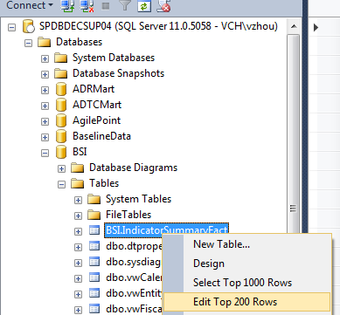

* Click “SQL” button on top left (This is to show SQL Pane)

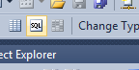

* Using the BSI excel sheet find EntityIndicatorIDs and add them as a where condition to the query
* For each indicator run the query separately

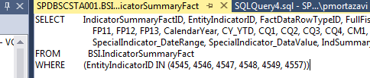

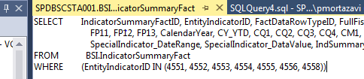

* Find the appropriate FullFiscalYear and update the appropriate quarter
* FactDataRowTypeID indicates whether you are updating the actual value or target

Note:

* FactDataRowTypeID = 1 is Actual values
* FactDataRowTypeID = 2 is Target Values

## Updating the Comments for BSI

* Write the comments that are appropriate for this quarter and review them with Ken Hawkins
* Before updating the comments send them to Directors of EndOfLife.
  + [Nancy.Desrosiers@vch.ca](mailto:Nancy.Desrosiers@vch.ca)
  + [Bob.Chapman@vch.ca](mailto:Bob.Chapman@vch.ca)
* Once they approve the comments you can update the comment section

Open the BSI Database on SQL

* Click in Databases -> BSI -> Dim.Indicator
* Add the where condition to the SQL query to specify which IndicatorIDs are required. Follow the previous steps

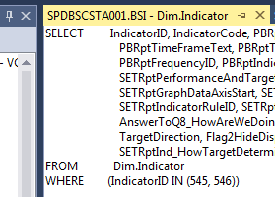

* Edit the text in “PBRptTimFrameText” and “SETptTimeFrameText” column to most recent update.

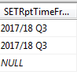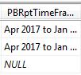

Prefixes of columns:

* “PBRpt” stands for Public Board Report
* “SETRpt” stands for Senior Executive Team Report
* Edit the comments in “SETRptIndicatorComments” and “AnswerToQ8_HowAreWeDoing” for both indicators and make sure that other comments are still valid.

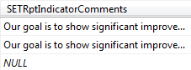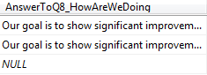

At this point, it is best to do a quick check to compare the BSI database with Palliative Balance Scorecard.

## Palliative Scorecard

To generate the Dashboard, click on the following link: <http://spdbsssrs001/Reports/report/BSI/Scorecard_SETReport_Overview>

* Under the Scorecard code, select Palliative and click “View Report” button at top-right corner

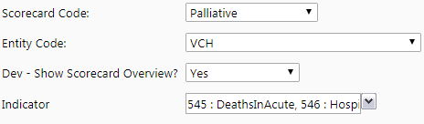

* Confirm that the dashboard and both indicators are accurate



* Export the file as a PDF

# **Quality Checks**

## Excel Files

When updating data and charts in the excel files, check that the tables, and pivots contain the most current period data. Also check for anomalies in the graphs shapes and YTD values.

Often data from previous periods may have been adjusted. Therefore, it is best to copy and paste from the earliest available data until the most recent. Before doing so, do a check to see if the earlier data had any major changes. If there are significant variances in earlier data, there may be a need for further investigation.

A great method to double check your data is to add the most recent values of each region and see if they it adds up to the VCH number.

## Palliative Scorecard

After updating both indicators in the BSI database, refresh the Palliative Balance Scorecard on the webpage.

On the scorecard homepage, check to see if the “Time Frame” text is updated to the most recent quarter/year. Then, double check to see if charts, target, and YTD for both indicators have been updated. Compare the chart on the dashboard to the chart in the Excel file to ensure that the basic trends in the graphs are consistent. Also, confirm that the target and YTD values are accurate.

# **Second Round of Quality Checks**

Complete these checks prior to sending out the report for review.

## Palliative Scorecard

Before sending off the report for review, do another comparison of Palliative Scorecard with source data files contained in the indicator

* Check “Time Frame” column to make sure the text is updated
* Check the trend in the graphs for any anomalies
* Make sure the target is correct
* Check YTD for both indicator

# **Updating the DASH**

To upload the data in DASH go the following webpage and follow the instructions: <https://vchphcdash.healthbc.org/tools-resources/Training%20and%20Tutorials/Pages/HowtoUploadStaticReports.aspx>

* Export both the EndOfLife Report and Palliative Scorecard as PDF
* Keep their original names (Regional End of Life Report and Palliative Scorecard)

# **Final Steps**

When both the report and the scorecard is finalized and uploaded in DASH, write a brief summary of the data and send them to Ken Hawkins for review and final sign-off.

Once approved, distribute it to Regional End of Life / Palliative Program members which can be found in the following folder and CC all SI Managers

